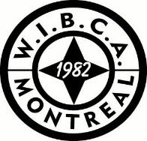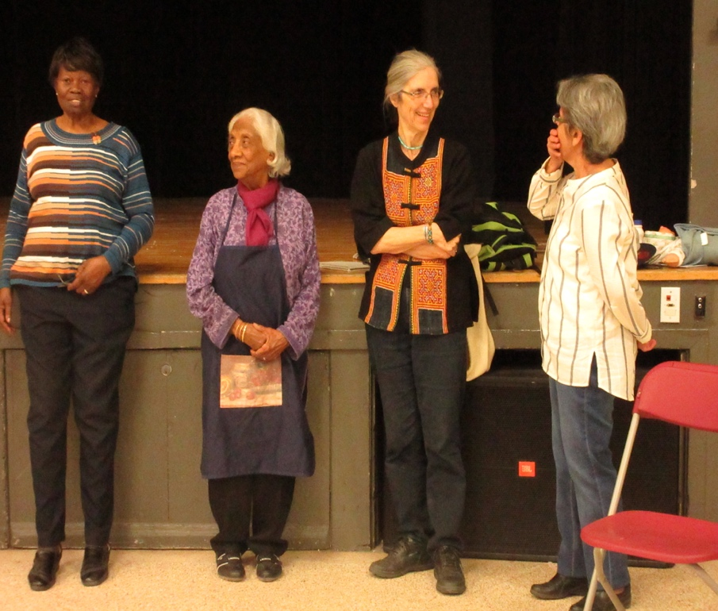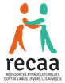

**«Towards a Culture of Respect»**

**Limited Places / Please confirm your attendance at the WIBCA Office by calling 514****▪683▪3925 or by email: admin@wibca.org or by calling 514▪624▪5037 by the latest, October 24, 2018**

**514 273-8061, poste 23**

# West Island Black Community Association (WIBCA) and RECAA

***Invite you to a theatre presentation written and acted by seniors.***

***“ELDER MISTREATMENT”***

Saturday, October 27, 2018

from 2:00 p. m. to 4:00 p. m.

West Island Black Community Association

48C 4th Avenue South

Roxboro, QC H8Y 2M2

(Rue Commercial)

Free entry!

Light refreshments will be served

Help us prevent abuse in all our communities

